**TUGAS ALGORITMA**

**“TUGAS 1** (Membuat Program Deret Bilangan dan Program Perhitungan Luas & Volume Suatu Bangun) **DAN TUGAS 2** (Membuat Program Rekapitulasi Bonus AkhirTahun Karyawan PT.AnginRibut dan Tugas Mandiri)**”**



**DISUSUN OLEH**

KELOMPOK 10

Nama : Arina Saffanah Zakiyyah (NIM-20220801189)

Andita Nurrizki Rahmani (NIM-20220801266)

Reza Prakosta (NIM-20220801010)

Yoga Dwi Sutarto (NIM-20220801284)

Fakultas : Ilmu Komputer

Program Studi : Teknik Informatika

**Universitas Esa Unggul**

**Tahun Ajaran 2022/2023**

**1A. MEMBUAT PROGRAM DERET KUBIK DAN DERET FIBONACCI**

#include<iostream>

using namespace std;

int main(){

//MEMBUAT PROGRAM DERET FIBONACCI

cout<<"========================"<<endl;

cout<<"PROGRAM C++ DERET KUBIK"<<endl;

cout<<"----OLEH KELOMPOK 10----"<<endl;

cout<<"========================"<<endl;

int jumlah_deret, suku, a;

float rata_rata, total_deret = 0;

cout<<"\nMasukkan jumlah deret yang diinginkan \t= ";

cin>>jumlah_deret;

cout<<endl;

for(int a = 1; a <= jumlah_deret; a++){

suku = a*a*a;

cout<<suku;

total_deret += suku; //total deret = total deret + suku.

if(a != jumlah_deret){

cout<<", ";

}

}

rata_rata = total_deret/jumlah_deret;

cout<<endl;

cout<<"\n---------------------------------------------------- "<<endl;

cout<<"Total dari jumlah deret tersebut \t= "<<total_deret<<endl;

cout<<"Rata-rata dari deret tersebut \t\t= "<<rata_rata<<endl;

cout<<"---------------------------------------------------- "<<endl;

//PROGRAM DERET KUBIK SELESAI

//MEMBUAT PROGRAM DERET FIBONACCI

cout<<"\n\n============================"<<endl;

cout<<"PROGRAM C++ DERET FIBONACCI"<<endl;

cout<<"------OLEH KELOMPOK 10------"<<endl;

cout<<"============================"<<endl;

int n;

float rata2, total;

int f1 = 0;

int f2 = 1;

int berikutnya = 0;

cout<<"\nMasukkan jumlah deret yang diinginkan \t= ";

cin>>n;

cout<<"\nDeret fibonacci : "<<endl;

cout<<f1<<", ";

cout<<f2<<", ";

total = f1 + f2;

for(int a = 3; a <= n; a++){

berikutnya = f1 + f2;

f1 = f2;

f2 = berikutnya;

cout<<berikutnya<<" ";

total = total + berikutnya;

if(a != n){

cout<<", ";

}

}

rata2 = total/n;

cout<<endl;

cout<<"\n---------------------------------------------------- "<<endl;

cout<<"Total dari jumlah deret tersebut \t= "<<total<<endl;

cout<<"Rata-rata dari deret tersebut \t\t= "<<rata2<<endl;

cout<<"---------------------------------------------------- "<<endl;

//PROGRAM DERET FIBONACCI SELESAI

return 0;

}

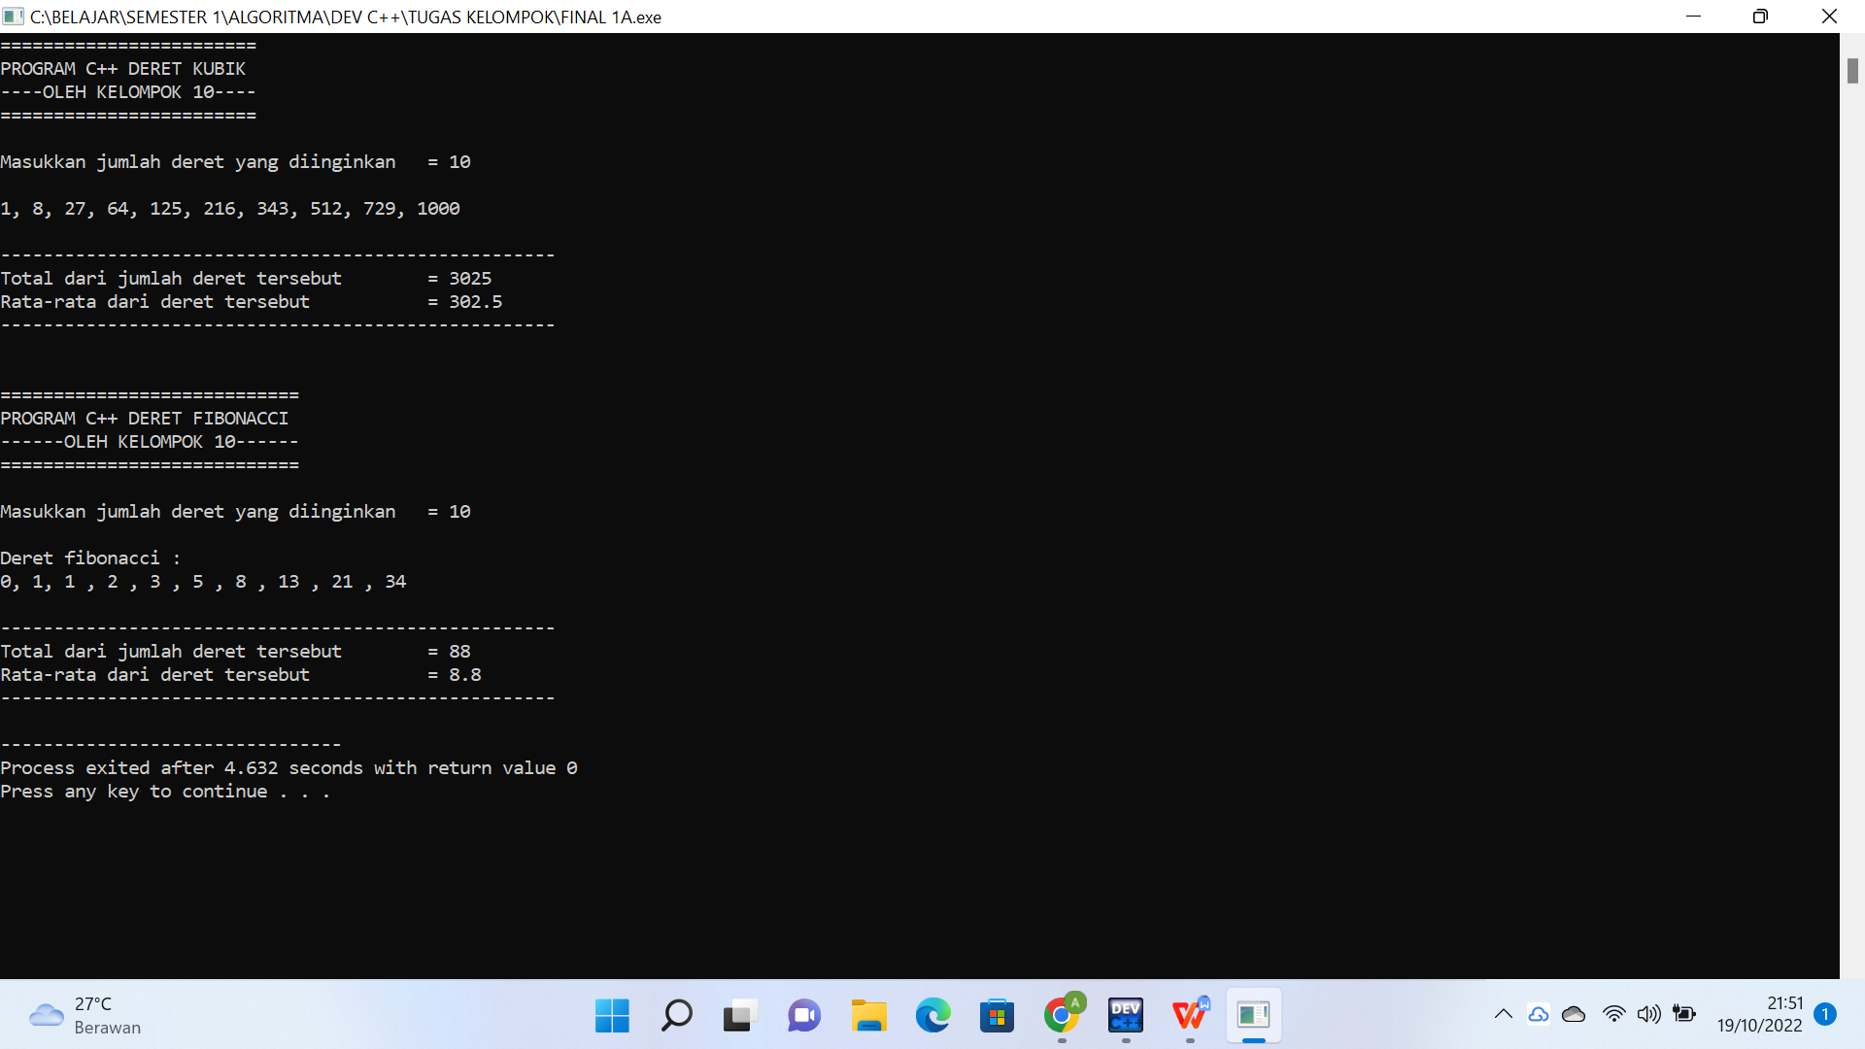

**1B. MEMBUAT PROGRAM DERET FAKTORIAL DAN DERET PRIMA**

#include<iostream>

using namespace std;

int main(){

//MEMBUAT PROGRAM DERET FAKTORIAL

cout<<"=========================================="<<endl;

cout<<"## Program C++ Deret Bilangan Faktorial ##"<<endl;

cout<<"-------------OLEH KELOMPOK 10-------------"<<endl;

cout<<"=========================================="<<endl;

cout<<endl;

int n, i;

long double hasil;

cout<<"Masukkan bilangan yang ingin difaktorialkan : ";

cin >>n;

cout<<endl;

cout<<n<<"! = ";

hasil = 1;

for ( i = n ; i >= 1; i--){

hasil = hasil*i;

//untuk menampilkan angka

cout<< i;

if(i != 1){

cout<<" * ";

}

}

cout<<" = "<<hasil<<endl;

cout<<"Hasil dari "<<n<<" faktorial adalah "<<hasil<<endl;

//PROGRAM DERET FAKTORIAL SELESAI

cout<<"\n\n======================================"<<endl;

cout<<"## Program C++ Deret Bilangan Prima ##"<<endl;

cout<<"-----------OLEH KELOMPOK 10-----------"<<endl;

cout<<"======================================"<<endl;

cout<<endl;

int batas, bil;

cout<<"Masukkan batas bilangan prima yang diinginkan : ";

cin>>batas;

cout<<endl;

cout<<"Deret bilangan prima : "<<endl;

for(int a = 1 ; a <= batas ; a++){

bil = 0;

for(int b = 1 ; b <= a; b++){

if(a % b == 0){

bil = bil + 1;

}

}

if(bil == 2){

cout<<a<<" ";

}

}

cout<<endl;

//PROGRAM DERET PRIMA SELESAI

return 0;

}

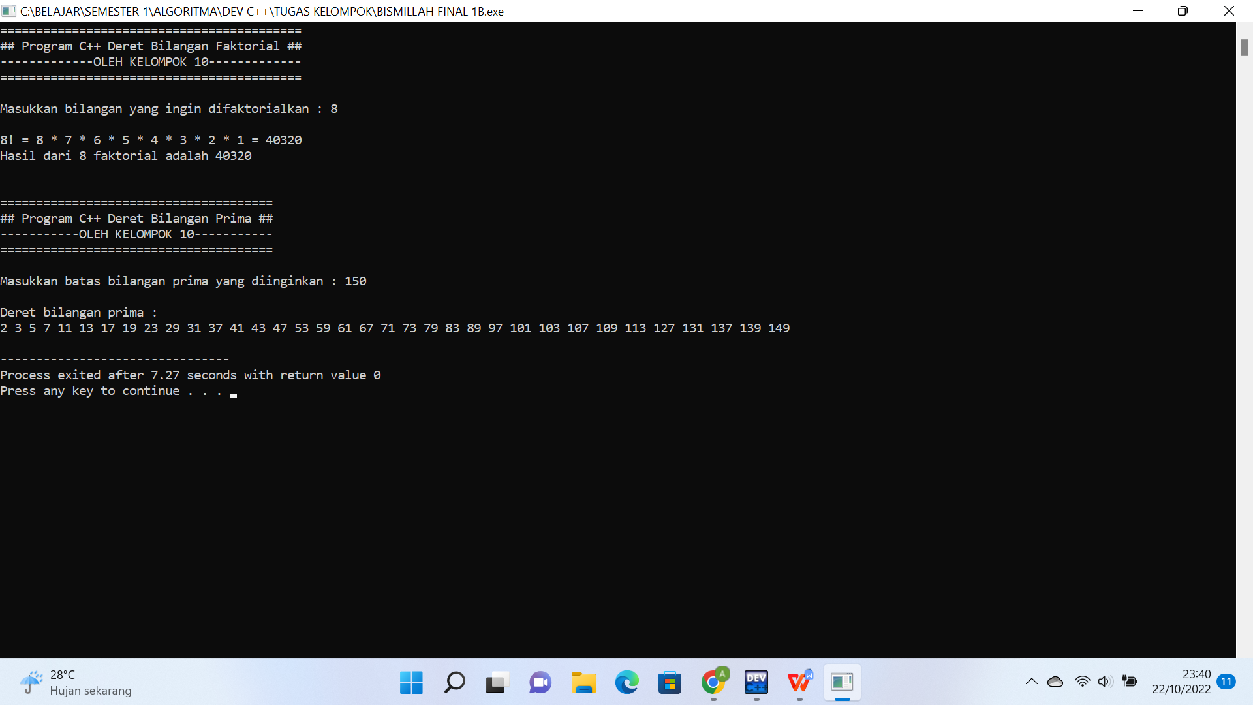

**2A. MEMBUAT PROGRAM PERHITUNGAN LUAS SEGITIGA DAN LUAS PERMUKAAN KUBUS**

#include <iostream>

using namespace std;

int main (){

//MEMBUAT PROGRAM MENGHITUNG LUAS SEGITIGA

cout<<"=========================================="<<endl;

cout<<"## Program C++ Menghitung Luas Segitiga ##"<<endl;

cout<<"-------------OLEH KELOMPOK 10-------------"<<endl;

cout<<"=========================================="<<endl;

cout<<endl;

int alas, tinggi, at;

float luas;

cout<< "Masukkan alas \t\t= ";

cin>>alas;

cout<<"Masukkan tinggi \t= ";

cin>>tinggi;

cout<<"--------------------------------"<<endl;

cout<<"\nAlas \t\t\t= "<<alas<<" cm "<<endl;

cout<<"Tinggi \t\t\t= "<<tinggi<<" cm "<<endl;

cout<<"--------------------------------"<<endl;

at = alas*tinggi;

luas = (alas*tinggi)/2;

cout<<"\nLuas segitiga = "<<endl;

cout<<"L = (alas x tinggi) : 2"<<endl;

cout<<"L = (a x t) : 2"<<endl;

cout<<"L = ("<<alas<<" x "<<tinggi<<") : 2 "<<endl;

cout<<"L = ("<<at<<") : 2"<<endl;

cout<<"L = "<<luas<<endl;

cout<<"\nLuas segitiga tersebut adalah "<<luas<<" cm2 "<<endl;

//PROGRAM MENGHITUNG LUAS SEGITIGA SELESAI

//MEMBUAT PROGRAM MENGHITUNG LUAS KUBUS

cout<<"\n\n========================================"<<endl;

cout<<"## Program C++ Menghitung Luas Kubus ##"<<endl;

cout<<"------------OLEH KELOMPOK 10------------"<<endl;

cout<<"========================================"<<endl;

cout<<endl;

int sisi, luas_kubus, ss; //ss = sisi x sisi

cout<<"Masukkan panjang sisi : ";

cin>>sisi;

cout<<"\nSisi (s) = "<< sisi <<" cm "<<endl;

ss = sisi*sisi;

luas_kubus = 6*(sisi*sisi);

cout<<"\nLuas Permukaan Kubus = "<<endl;

cout<<"L = 6 x (sisi x sisi)"<<endl;

cout<<"L = 6 x ("<<sisi<<" x "<<sisi<<")"<<endl;

cout<<"L = 6 x "<<ss<<endl;

cout<<"L = "<<luas_kubus<<endl;

cout<<"\nLuas permukaan kubus tersebut adalah "<<luas_kubus<<" cm2 "<<endl;

return 0;

}

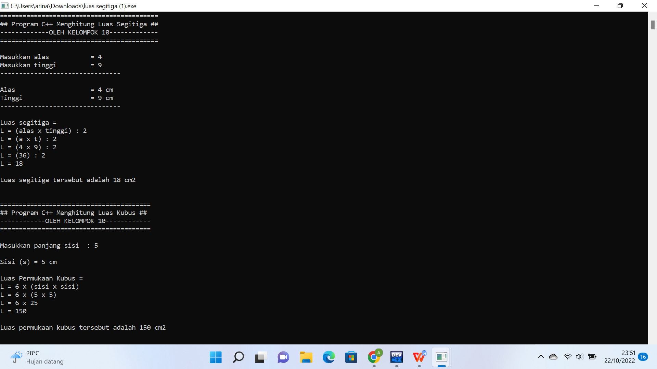

**2B. MEMBUAT PROGRAM PERHITUNGAN LUAS LINGKARAN DAN LUAS PERMUKAAN ISI BOLA**

#include <iostream>

using namespace std;

int main (){

//MEMBUAT PROGRAM MENGHITUNG LUAS LINGKARAN

cout<<"==========================================="<<endl;

cout<<"## Program C++ Menghitung Luas Lingkaran ##"<<endl;

cout<<"-------------OLEH KELOMPOK 10--------------"<<endl;

cout<<"==========================================="<<endl;

cout<<endl;

float phi, luas, jari_jari, r2, r3, luas1;

cout<< "Masukkan jari-jari lingkaran (r) = ";

cin>>jari_jari;

cout<<"-------------------------------------------"<<endl;

cout<<"\nJari-jari (r) \t\t\t = "<<jari_jari<<" cm "<<endl;

cout<<"-------------------------------------------"<<endl;

phi = 3.14;

r2 = jari_jari*jari_jari;

luas = phi * (jari_jari*jari_jari);

cout<<"\nLuas lingkaran = "<<endl;

cout<<"L = phi x (jari-jari x jari-jari)"<<endl;

cout<<"L = phi x (r x r)"<<endl;

cout<<"L = 3,14 x ("<<jari_jari<<" x "<<jari_jari<<")"<<endl;

cout<<"L = 3,14 x ("<<r2<<") "<<endl;

cout<<"L = "<<luas<<endl;

cout<<"\nLuas lingkaran tersebut adalah "<<luas<<" cm2 "<<endl;

//PROGRAM MENGHITUNG LUAS LINGKARAN SELESAI

//MEMBUAT PROGRAM MENGHITUNG VOLUME ISI BOLA

cout<<"\n============================================="<<endl;

cout<<"## Program C++ Menghitung Volume Isi bola ##"<<endl;

cout<<"---------------OLEH KELOMPOK 10--------------"<<endl;

cout<<"============================================="<<endl;

cout<<endl;

cout<< "Masukkan jari-jari bola (r) \t= ";

cin>>jari_jari;

cout<<"---------------------------------------------"<<endl;

cout<<"\nJari-jari (r) \t\t\t= "<<jari_jari<<" cm "<<endl;

cout<<"---------------------------------------------"<<endl;

phi = 3.14;

r3 = jari_jari*jari_jari*jari_jari;

luas1 = (4 * phi * (jari_jari*jari_jari*jari_jari));

luas = (4 * phi * (jari_jari*jari_jari*jari_jari))/3;

cout<<"\nVolume isi bola = "<<endl;

cout<<"L = 4/3 x phi x (jari-jari x jari-jari x jari-jari)"<<endl;

cout<<"L = 4/3 x phi x (r x r x r)"<<endl;

cout<<"L = 4/3 x 3,14 x ("<<jari_jari<<" x "<<jari_jari<<" x" <<jari_jari<<")"<<endl;

cout<<"L = 4/3 x 3,14 x ("<<r3<<") "<<endl;

cout<<"L = ("<<luas1<<")/3 "<<endl;

cout<<"L = "<<luas<<endl;

cout<<"\nVolume isi bola tersebut adalah "<<luas<<" cm3 "<<endl;

//PROGRAM MENGHITUNG VOLUME ISI BOLA SELESAI

return 0;

}

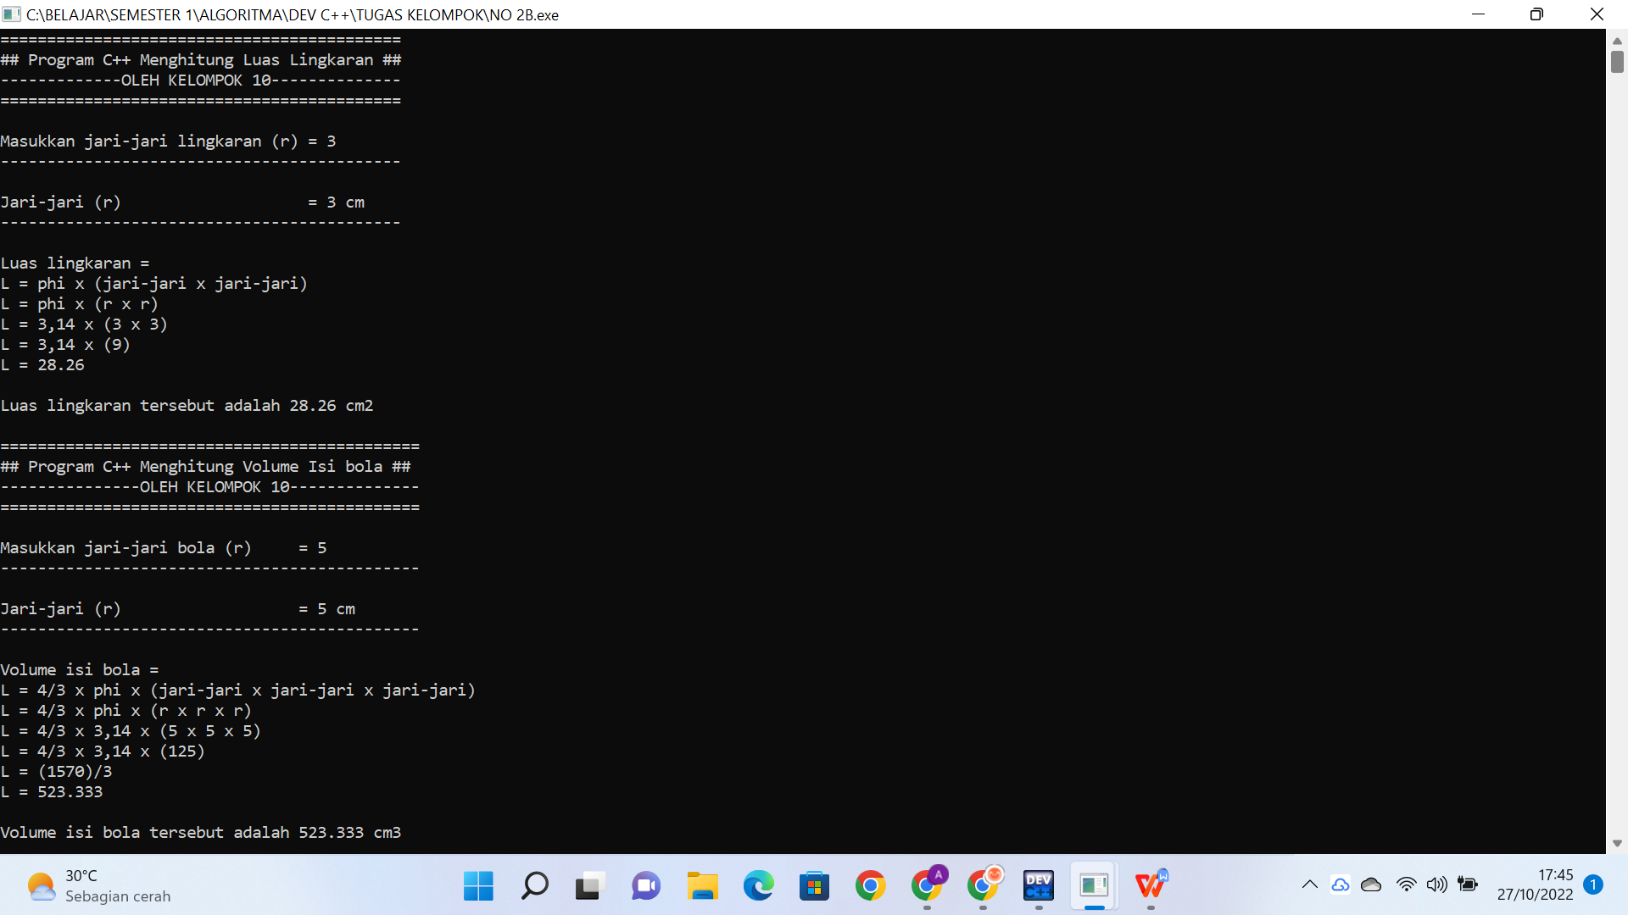

**3A. MEMBUAT PROGRAM DERET BILANGAN GENAP DAN DERET BILANGAN GANJIL**

#include <iostream>

using namespace std;

int main (){

//MEMBUAT PROGRAM DERET BILANGAN GENAP

cout<<"=================================================="<<endl;

cout<<" ## Program C++ DERET BILANGAN GENAP & GANJIL ## "<<endl;

cout<<"-----------------OLEH KELOMPOK 10-----------------"<<endl;

cout<<"=================================================="<<endl;

cout<<endl;

int batas_genap, batas_ganjil;

cout<<"--------------------------------------------------"<<endl;

cout<<"Masukkan batas deret genap yang diinginkan = ";

cin>>batas_genap;

cout<<"--------------------------------------------------"<<endl;

cout<<endl;

cout<<"Deret bilangan genap : "<<endl;

for(int a = 1 ; a <= batas_genap ; a++){

if (a % 2 == 0){

cout<<a;

if (a != batas_genap && a != (batas_genap - 1)){

cout<<", ";

}

}

}

cout<<endl;

//PROGRAM DERET BILANGAN GENAP SELESAI

//MEMBUAT PROGRAM DERET BILANGAN GANJIL

cout<<"\n\n-------------------------------------------------- "<<endl;

cout<<"Masukkan batas deret ganjil yang diinginkan = ";

cin>>batas_ganjil;

cout<<"--------------------------------------------------"<<endl;

cout<<endl;

cout<<"Deret bilangan ganjil : "<<endl;

for(int b = 1 ; b <= batas_ganjil ; b++){

if (b % 2 == 1){

cout<<b;

if (b != batas_ganjil && b != (batas_ganjil - 1)){

cout<<", ";

}

}

}

cout<<"\n\n"<<endl;

//PROGRAM DERET BILANGAN GENAP SELESAI

return 0;

}

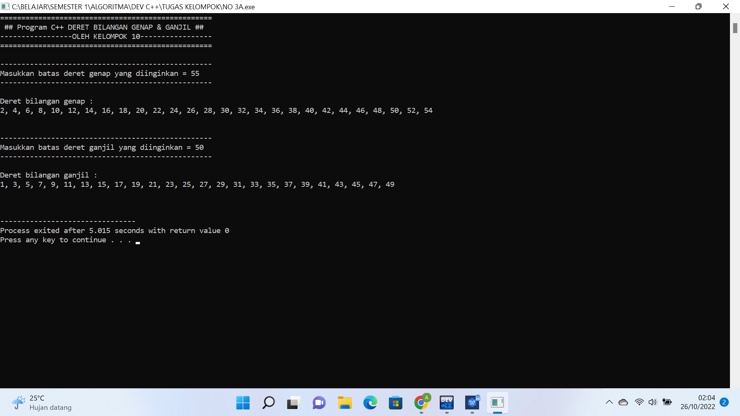

**3B. MEMBUAT PROGRAM DERET BILANGAN INCREMENT DAN DECREMENT**

#include <iostream>

using namespace std;

int main (){

//MEMBUAT PROGRAM DERET BILANGAN INCREMENT (MENAIK)

cout<<"======================================================="<< endl;

cout<<" ## Program C++ DERET BILANGAN INCREMENT & DECREMENT ## "<<endl;

cout<<"-------------------OLEH KELOMPOK 10-------------------- "<<endl;

cout<<"======================================================="<< endl;

cout<<endl;

int batas_increment, batas_decrement;

cout<<"------------------------------------------------------- "<<endl;

cout<<"Masukkan batas deret increment diinginkan = ";

cin>>batas_increment;

cout<<"------------------------------------------------------- "<<endl;

cout<<endl;

cout<<"Deret bilangan increment (menaik) : "<<endl;

for(int a = 1 ; a <= batas_increment ; a++){

cout<<a;

if (a != batas_increment){

cout<<", ";

}

}

cout<<endl;

//PROGRAM DERET BILANGAN INCREMENT (MENAIK) SELESAI

//MEMBUAT PROGRAM DERET BILANGAN DECREMENT (MENURUN)

cout<<"\n\n------------------------------------------------------ -------------------"<<endl;

cout<<"Masukkan bilangan yang diinginkan untuk memulai deret decrement = ";

cin>>batas_decrement;

cout<<"---------------------------------------------------------- ---------------"<<endl;

cout<<endl;

cout<<"Deret bilangan decrement (menurun) : "<<endl;

for(int b = batas_decrement ; b >= 1 ; b--){

cout<<b;

if (b != 1){

cout<<", ";

}

}

cout<<"\n\n"<<endl;

//PROGRAM DERET BILANGAN DECREMENT (MENURUN) SELESAI

return 0;

}

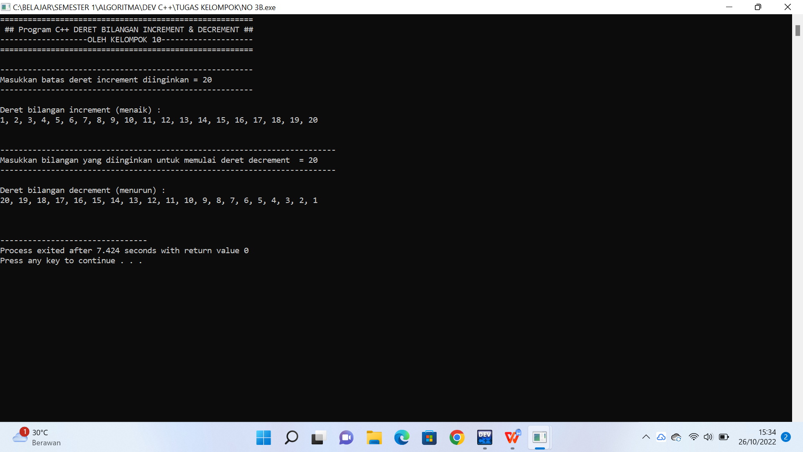

TUGAS KELOMPOK KE-2

#include <iostream>

#include <iomanip>

#include <conio.h>

#include <windows.h>

using namespace std;

void gotoxy(int x, int y)

{

//HANDLE hConsoleOutput;

//COORD dwCursorPosition;

//cout.flush();

//dwCursorPosition.X = x;

//dwCursorPosition.Y = y;

//hConsoleOutput = GetStdHandle(STD_OUTPUT_HANDLE);

COORD coord;

coord.X = x;

coord.Y = y;

SetConsoleCursorPosition(GetStdHandle(STD_OUTPUT_HANDLE), coord);

}

//deklarasi menggunakan global scope

int jmlAnak[15];

double masaKerja[15], sanksi[15],mkTabel[15], sanksiTabel[15];

string nip[15], nama[15], status[15];

string jabatan[15] = {"Direktur", "Direktur", "Direktur", "Direktur", "Direktur", "Manajer", "Manajer", "Manajer", "Manajer", "Manajer", "Karyawan", "Karyawan","Karyawan", "Karyawan", "Karyawan"};

double bonus[15], tunjAnak[15], gajiBersih [15];

double gaji[15] = {20000000, 20000000, 20000000, 20000000, 20000000, 15000000, 15000000, 15000000, 15000000, 15000000, 7000000, 7000000, 7000000, 7000000, 7000000};

double totGaji = 0, totBonus = 0, totTunjAnak = 0, totGajiBersih = 0;

//potongan gaji karyawan untuk menghitung gaji bersih

//potongan iuran BPJS

double ijk = 0.05, ijkk = 0.00174, ijkm = 0.003, ijht = 0.057, ijp = 0.03;

double jk[15], jkk[15], jkm[15], jht[15], jp[15];

//total perjabatan di halaman terakhir

double tgp1 = 0, tgp2 = 0, tgp3 = 0, tbp1 = 0, tbp2 = 0, tbp3 = 0, ttp1 = 0, ttp2 = 0, ttp3 = 0, tgbp1 = 0, tgbp2 = 0, tgbp3 = 0;

void tabel1(){

gotoxy(40,0);cout<<"Rekapitulasi Bonus AkhirTahun Karyawan PT.AnginRibut";

gotoxy(1,21);cout<<"[JABATAN : DIREKTUR]";

gotoxy(108,21);cout<<"HALAMAN 1";

gotoxy(1,22);cout<<"============================================= ================================================================= ====== ";

gotoxy(1,23);cout<<"| NO | NIP | NAMA | STATUS | JML ANAK | JABATAN | GAJI | BONUS Akh-TAHUN | TUNJ ANAK | GAJI BERSIH | ";

gotoxy(1,24);cout<<"============================================= ================================================================= ====== ";

for(int i = 1; i <= 5; i++)

{

gotoxy(1,24+i);

cout<<"| | | | | | | | | | |";

}

gotoxy(1,30);cout<<"============================================= ================================================================= ====== ";

gotoxy(1,31);cout<<"| TOTAL GAJI| | ";

gotoxy(1,32);cout<<"| TOTAL BONUS| | ";

gotoxy(1,33);cout<<"| TOTAL TUNJANGAN ANAK| | ";

gotoxy(1,34);cout<<"| TOTAL GAJI BERSIH| | ";

gotoxy(1,35);cout<<"============================================= ================================================================= ====== ";

}

void tabel2(){

gotoxy(1,39);cout<<"[JABATAN : WAKIL DIREKTUR]";

gotoxy(108,39);cout<<"HALAMAN 2";

gotoxy(1,40);cout<<"============================================= ================================================================= ====== ";

gotoxy(1,41);cout<<"| NO | NIP | NAMA | STATUS | JML ANAK | JABATAN | GAJI | BONUS Akh-TAHUN | TUNJ ANAK | GAJI BERSIH |";

gotoxy(1,42);cout<<"============================================= ================================================================= ====== ";

for(int i = 1; i <= 5; i++)

{

gotoxy(1,42+i);

cout<<"| | | | | | | | | | |";

}

gotoxy(1,48);cout<<"============================================= ================================================================= ====== ";

gotoxy(1,49);cout<<"| TOTAL GAJI| | ";

gotoxy(1,50);cout<<"| TOTAL BONUS| | ";

gotoxy(1,51);cout<<"| TOTAL TUNJANGAN ANAK| | ";

gotoxy(1,52);cout<<"| TOTAL GAJI BERSIH| | ";

gotoxy(1,53);cout<<"============================================= ================================================================= ====== ";

}

void tabel3(){

gotoxy(1,57);cout<<"[JABATAN : MANAJER]";

gotoxy(108,57);cout<<"HALAMAN 3";

gotoxy(1,58);cout<<"============================================= ================================================================= ====== ";

gotoxy(1,59);cout<<"| NO | NIP | NAMA | STATUS | JML ANAK | JABATAN | GAJI | BONUS Akh-TAHUN | TUNJ ANAK | GAJI BERSIH |";

gotoxy(1,60);cout<<"============================================= ================================================================= ====== ";

for(int i = 1; i <= 5; i++)

{

gotoxy(1,60+i);

cout<<"| | | | | | | | | | |";

}

gotoxy(1,66);cout<<"============================================= ================================================================= ====== ";

gotoxy(1,67);cout<<"| TOTAL GAJI| | ";

gotoxy(1,68);cout<<"| TOTAL BONUS| | ";

gotoxy(1,69);cout<<"| TOTAL TUNJANGAN ANAK| | ";

gotoxy(1,70);cout<<"| TOTAL GAJI BERSIH| | ";

gotoxy(1,71);cout<<"============================================= ================================================================= ====== ";

}

void input1(){

double totGaji = 0, totBonus = 0, totTunjAnak = 0, totGajiBersih = 0;

for (int i = 0; i < 5; i++){

gotoxy(3,25+i);cout<<i+1;

gotoxy(1,2);cout<<"Masukkan NIP \t\t\t= ";

cin >> nip[i];

gotoxy(7,25+i);cout << nip[i];

gotoxy(1,3);cout<<"Masukkan nama \t\t\t= ";

cin >> nama[i];

gotoxy(15,25+i);cout << nama[i];

gotoxy(1,4);cout<<"Masukkan status (SM/BM) \t= ";

cin >> status[i];

gotoxy(33,25+i);cout << status[i];

gotoxy(1,5);cout<<"Masukkan jumlah anak \t\t= ";

cin >> jmlAnak[i];

gotoxy(43,25+i);cout << jmlAnak[i];

gotoxy(1,6);cout<<"Masa kerja : \t\t1. < 1 tahun\n\t\t\t\t2. 1-4 tahun\n\t\t\t\t3. 5-9 tahun\n\t\t\t\t4. >= 10 tahun";

gotoxy(1,10);cout<<"Pilih angka yang sesuai \t= ";

cin >> masaKerja[i];

if (masaKerja[i]==1){

mkTabel[i] = 0.8;

} else if (masaKerja[i]==2){

mkTabel[i] = 0.9;

} else if (masaKerja[i]==3){

mkTabel[i] = 1;

} else if (masaKerja[i]==4){

mkTabel[i] = 1.2;

} else {

}

gotoxy(1,11);cout<<"sanksi surat peringatan : 1. tanpa sanksi\n\t\t\t\t2. SP I\n\t\t\t\t3. SP II\n\t\t\t\t4. SP III";

gotoxy(1,15);cout<<"Pilih angka yang sesuai \t= ";

cin >> sanksi[i];

if (sanksi[i]==1){

sanksiTabel[i] = 1;

} else if (sanksi[i]==2){

sanksiTabel[i] = 0.9;

} else if (sanksi[i]==3){

sanksiTabel[i] = 0.8;

} else if (sanksi[i]==4){

sanksiTabel[i] = 0.7;

} else {

}

gotoxy(50,25+i);cout << jabatan[i];

gotoxy(60,25+i);cout << setprecision(10) << gaji[i] ;

bonus[i] = (mkTabel[i] * 1.2 * 1 * gaji[i]) * sanksiTabel[i];

gotoxy(73,25+i);cout << bonus[i];

tunjAnak[i] = (gaji[i] * 0.02) * jmlAnak[i];

gotoxy(91,25+i);cout << tunjAnak[i];

jk[i] = ijk * gaji[i];

jkk[i] = ijkk * gaji[i];

jkm[i] = ijkm * gaji[i];

jht[i] = ijht * gaji[i];

jp[i] = ijp * gaji[i];

gajiBersih[i] = (gaji[i] + bonus[i] + tunjAnak[i]) - (jk[i] + jkk[i] + jkm[i] + jht[i] + jp[i]);

gotoxy(103,25+i);cout << gajiBersih[i];

totGaji = totGaji + gaji[i];

gotoxy(100,31);cout << totGaji;

tgp1 = totGaji;

totBonus = totBonus + bonus[i];

gotoxy(100,32);cout << totBonus;

tbp1 = totBonus;

totTunjAnak = totTunjAnak + tunjAnak[i];

gotoxy(100,33);cout << totTunjAnak;

ttp1 = totTunjAnak;

totGajiBersih = totGajiBersih + gajiBersih[i];

gotoxy(100,34);cout << totGajiBersih;

tgbp1 = totGajiBersih;

gotoxy(34,2);cout<<" ";

gotoxy(34,3);cout<<" ";

gotoxy(34,4);cout<<" ";

gotoxy(34,5);cout<<" ";

gotoxy(34,10);cout<<" ";

gotoxy(34,15);cout<<" ";

gotoxy(34,17);cout<<" ";

}

}

void input2(){

double totGaji = 0, totBonus = 0, totTunjAnak = 0, totGajiBersih = 0;

for (int j = 5 ; j < 10 ; j++){

gotoxy(3,38+j);cout<<j-4;

gotoxy(1,2);cout<<"Masukkan NIP \t\t\t= ";

cin >> nip[j];

gotoxy(7,38+j);cout << nip[j];

gotoxy(1,3);cout<<"Masukkan nama \t\t\t= ";

cin >> nama[j];

gotoxy(15,38+j);cout << nama[j];

gotoxy(1,4);cout<<"Masukkan status (SM/BM) \t= ";

cin >> status[j];

gotoxy(33,38+j);cout << status[j];

gotoxy(1,5);cout<<"Masukkan jumlah anak \t\t= ";

cin >> jmlAnak[j];

gotoxy(43,38+j);cout << jmlAnak[j];

gotoxy(1,6);cout<<"Masa kerja : \t\t1. < 1 tahun\n\t\t\t\t2. 1-4 tahun\n\t\t\t\t3. 5-9 tahun\n\t\t\t\t4. >= 10 tahun";

gotoxy(1,10);cout<<"Pilih angka yang sesuai \t= ";

cin >> masaKerja[j];

if (masaKerja[j]==1){

mkTabel[j] = 0.8;

} else if (masaKerja[i]==2){

mkTabel[j] = 0.9;

} else if (masaKerja[i]==3){

mkTabel[j] = 1;

} else if (masaKerja[i]==4){

mkTabel[j] = 1.2;

} else {

}

gotoxy(1,11);cout<<"sanksi surat peringatan : 1. tanpa sanksi\n\t\t\t\t2. SP I\n\t\t\t\t3. SP II\n\t\t\t\t4. SP III";

gotoxy(1,15);cout<<"Pilih angka yang sesuai \t= ";

cin >> sanksi[j];

if (sanksi[j]==1){

sanksiTabel[j] = 1;

} else if (sanksi[j]==2){

sanksiTabel[j] = 0.9;

} else if (sanksi[j]==3){

sanksiTabel[j] = 0.8;

} else if (sanksi[j]==4){

sanksiTabel[j] = 0.7;

} else {

}

gotoxy(50,38+j);cout << jabatan[j];

gotoxy(60,38+j);cout << setprecision(10) << gaji[j] ;

bonus[j] = (mkTabel[j] * 1 * 1 * gaji[j]) * sanksiTabel[j];

gotoxy(73,38+j);cout << bonus[j];

tunjAnak[j] = (gaji[j] * 0.02) * jmlAnak[j];

gotoxy(91,38+j);cout << tunjAnak[j];

jk[j] = ijk * gaji[j];

jkk[j] = ijkk * gaji[j];

jkm[j] = ijkm * gaji[j];

jht[j] = ijht * gaji[j];

jp[j] = ijp * gaji[j];

gajiBersih[j] = (gaji[j] + bonus[j] + tunjAnak[j]) - (jk[j] + jkk[j] + jkm[j] + jht[j] + jp[j]);

gotoxy(103,38+j);cout << gajiBersih[j];

totGaji = totGaji + gaji[j];

gotoxy(100,49);cout << totGaji;

tgp2 = totGaji;

totBonus = totBonus + bonus[j];

gotoxy(100,50);cout << totBonus;

tbp2 = totBonus;

totTunjAnak = totTunjAnak + tunjAnak[j];

gotoxy(100,51);cout << totTunjAnak;

ttp2 = totTunjAnak;

totGajiBersih = totGajiBersih + gajiBersih[j];

gotoxy(100,52);cout << totGajiBersih;

tgbp2 = totGajiBersih;

gotoxy(34,2);cout<<" ";

gotoxy(34,3);cout<<" ";

gotoxy(34,4);cout<<" ";

gotoxy(34,5);cout<<" ";

gotoxy(34,10);cout<<" ";

gotoxy(34,15);cout<<" ";

gotoxy(34,17);cout<<" ";

}

}

void input3(){

double totGaji = 0, totBonus = 0, totTunjAnak = 0, totGajiBersih = 0;

for (int k = 10 ; k < 15 ; k++){

gotoxy(3,51+k);cout<<k-9;

gotoxy(1,2);cout<<"Masukkan NIP \t\t\t= ";

cin >> nip[k];

gotoxy(7,51+k);cout << nip[k];

gotoxy(1,3);cout<<"Masukkan nama \t\t\t= ";

cin >> nama[k];

gotoxy(15,51+k);cout << nama[k];

gotoxy(1,4);cout<<"Masukkan status (SM/BM) \t= ";

cin >> status[k];

gotoxy(33,51+k);cout << status[k];

gotoxy(1,5);cout<<"Masukkan jumlah anak \t\t= ";

cin >> jmlAnak[k];

gotoxy(43,51+k);cout << jmlAnak[k];

gotoxy(1,6);cout<<"Masa kerja : \t\t1. < 1 tahun\n\t\t\t\t2. 1-4 tahun\n\t\t\t\t3. 5-9 tahun\n\t\t\t\t4. >= 10 tahun";

gotoxy(1,10);cout<<"Pilih angka yang sesuai \t= ";

cin >> masaKerja[k];

if (masaKerja[k]==1){

mkTabel[k] = 0.8;

} else if (masaKerja[i]==2){

mkTabel[k] = 0.9;

} else if (masaKerja[i]==3){

mkTabel[k] = 1;

} else if (masaKerja[i]==4){

mkTabel[k] = 1.2;

} else {

}

gotoxy(1,11);cout<<"sanksi surat peringatan : 1. tanpa sanksi\n\t\t\t\t2. SP I\n\t\t\t\t3. SP II\n\t\t\t\t4. SP III";

gotoxy(1,15);cout<<"Pilih angka yang sesuai \t= ";

cin >> sanksi[k];

if (sanksi[k]==1){

sanksiTabel[k] = 1;

} else if (sanksi[k]==2){

sanksiTabel[k] = 0.9;

} else if (sanksi[k]==3){

sanksiTabel[k] = 0.8;

} else if (sanksi[j]==4){

sanksiTabel[k] = 0.7;

} else {

}

gotoxy(50,51+k);cout << jabatan[k];

gotoxy(60,51+k);cout << setprecision(10) << gaji[k] ;

bonus[k] = (mkTabel[k] * 0.8 * 1 * gaji[k]) * sanksiTabel[k];

gotoxy(73,51+k);cout << bonus[k];

tunjAnak[k] = (gaji[k] * 0.02) * jmlAnak[k];

gotoxy(91,51+k);cout << tunjAnak[k];

jk[k] = ijk * gaji[k];

jkk[k] = ijkk * gaji[k];

jkm[k] = ijkm * gaji[k];

jht[k] = ijht * gaji[k];

jp[k] = ijp * gaji[k];

gajiBersih[k] = (gaji[k] + bonus[k] + tunjAnak[k]) - (jk[k] + jkk[k] + jkm[k] + jht[k] + jp[k]);

gotoxy(103,51+k);cout << gajiBersih[k];

totGaji = totGaji + gaji[k];

gotoxy(100,67);cout << totGaji;

tgp3 = totGaji;

totBonus = totBonus + bonus[k];

gotoxy(100,68);cout << totBonus;

tbp3 = totBonus;

totTunjAnak = totTunjAnak + tunjAnak[k];

gotoxy(100,69);cout << totTunjAnak;

ttp3 = totTunjAnak;

totGajiBersih = totGajiBersih + gajiBersih[k];

gotoxy(100,70);cout << totGajiBersih;

tgbp3 = totGajiBersih;

gotoxy(34,2);cout<<" ";

gotoxy(34,3);cout<<" ";

gotoxy(34,4);cout<<" ";

gotoxy(34,5);cout<<" ";

gotoxy(34,10);cout<<" ";

gotoxy(34,15);cout<<" ";

gotoxy(34,17);cout<<" ";

}

}

void total(){

double totGaji = 0, totBonus = 0, totTunjAnak = 0, totGajiBersih = 0;

for (int l = 0; l < 15 ; l++){

totGaji = totGaji + gaji[l];

totBonus = totBonus + bonus[l];

totTunjAnak = totTunjAnak + tunjAnak[l];

totGajiBersih = totGajiBersih + gajiBersih[l];

gotoxy(1,74);cout << "Total gaji perjabatan : [DIREKTUR] --> " << setw (11) << tgp1;

gotoxy(1,75);cout << "Total gaji perjabatan : [MANAJER] --> " << setw (11) << tgp2;

gotoxy(1,76);cout << "Total gaji perjabatan : [KARYAWAN] --> " << setw (11) << tgp3;

gotoxy(1,78);cout << "Total bonus perjabatan : [DIREKTUR] --> " << setw (11) << tbp1;

gotoxy(1,79);cout << "Total bonus perjabatan : [MANAJER] --> " << setw (11) << tbp2;

gotoxy(1,80);cout << "Total bonus perjabatan : [KARYAWAN] --> " << setw (11) << tbp3;

gotoxy(1,82);cout << "Total tunjangan perjabatan : [DIREKTUR] --> " << setw (11) << ttp1;

gotoxy(1,83);cout << "Total tunjangan perjabatan : [MANAJER] --> " << setw (11) << ttp2;

gotoxy(1,84);cout << "Total tunjangan perjabatan : [KARYAWAN] --> " << setw (11) << ttp3;

gotoxy(1,86);cout << "Total gaji bersih perjabatan : [DIREKTUR] --> " << setw (11) << tgbp1;

gotoxy(1,87);cout << "Total gaji bersih perjabatan : [MANAJER] --> " << setw (11) << tgbp2;

gotoxy(1,88);cout << "Total gaji bersih perjabatan : [KARYAWAN] --> " << setw (11) << tgbp3;

gotoxy(1,91);cout << "Total keseluruhan ";

gotoxy(1,92);cout << "Halaman \t\t\t: 001 s/d 003";

gotoxy(1,93);cout << "Total Gaji \t\t\t: " << setw (11) << totGaji;

gotoxy(1,94);cout << "Total Bonus \t\t\t: " << setw (11) << totBonus;

gotoxy(1,95);cout << "Total Tunjangan Anak \t\t: " << setw (11) << totTunjAnak;

gotoxy(1,96);cout << "Total Gaji Bersih \t\t: " << setw (11) << totGajiBersih;

}

}

int main (){

gotoxy(40,0);cout<<"Rekapitulasi Bonus AkhirTahun Karyawan PT.AnginRibut";

tabel1();

tabel2();

tabel3();

input1();

input2();

input3();

total();

return 0;

system("pause>0");

}

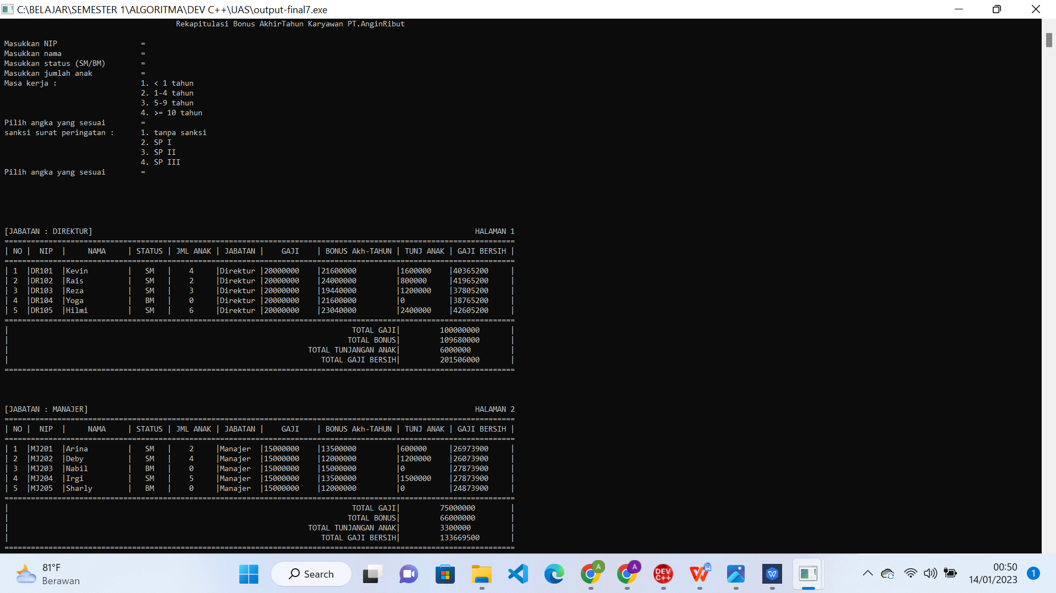

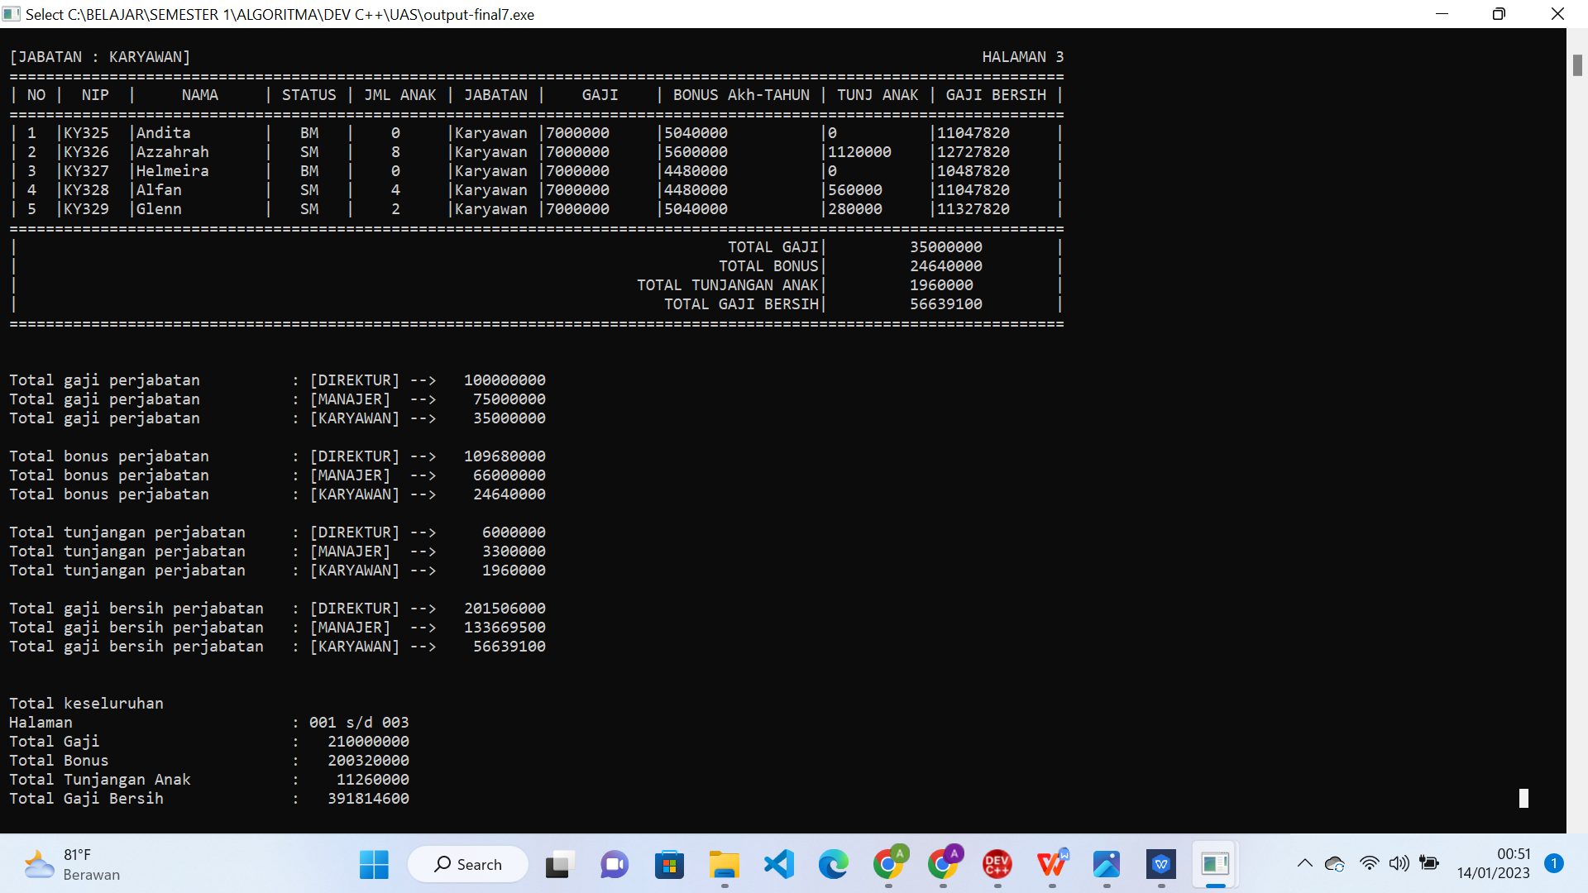

**2. MEMBUAT PROGRAM DENGAN MENENTUKAN KASUS SENDIRI (TUGAS MANDIRI)**

CASE : MEMBUAT PROGRAM UNTUK MENDAFTAR KELAS TAMBAHAN (Tutorial Service Time)

#include <iostream>

#include <iomanip>

#include <conio.h>

#include <windows.h>

using namespace std;

void gotoxy(int x, int y)

{

//HANDLE hConsoleOutput;

//COORD dwCursorPosition;

//cout.flush();

//dwCursorPosition.X = x;

//dwCursorPosition.Y = y;

//hConsoleOutput = GetStdHandle(STD_OUTPUT_HANDLE);

COORD coord;

coord.X = x;

coord.Y = y;

SetConsoleCursorPosition(GetStdHandle(STD_OUTPUT_HANDLE), coord);

}

//Membuat program TST (Tutorial Service Time) yaitu layanan konsul PR, tugas sekolah, menyelesaikan soal-soal sulit, dan lainnya secara gratis.

//deklarasi global

string ruangan[1];

string nama[1], hari[1], no[1], kelas[1], oHari[1], oMapel[1], oJam[1];

string mapel1[4] = {"Matematika","Fisika","Kimia","Biologi"};

string mapel2[4] = {"Matematika","Fisika","Kimia","Biologi"};

string mapel3[4] = {"Matematika","Fisika ","Kimia ","Biologi"};

string mapel4[4] = {"Matematika","Fisika","Kimia ","Biologi"};

string jam[4] = {"9-11","10-12","13-15","16-18"};

string jwb[1], jwbHari[1], jwbMapel[1];

int pilHari[1], pilMapel[1], pilHariLagi[1];

string tanggal[1];

void jadwal(){

gotoxy(0,4);cout<<"DAFTAR JADWAL TST MINGGU INI : ";

----------------------------------------------------------- --------------------";

gotoxy(5,6);cout<<"SENIN";

gotoxy(35,6);cout<<"SELASA";

gotoxy(65,6);cout<<"RABU";

gotoxy(100,6);cout<<"KAMIS";

gotoxy(0,12);cout<<"--------------------------------------- ----------------------------------------------------------- ---------------------";

for(int i=0 ; i<4; i++){

gotoxy(0,8+i);cout<<i+1<<")";

gotoxy(5,8+i);cout<<mapel1[i]<<"\t"<< setw (1) << "(" << jam[i] << ")";

}

for(int i=0 ; i<4; i++){

gotoxy(30,8+i);cout<<i+1<<")";

gotoxy(35,8+i);cout<<mapel2[i]<<"\t"<< setw (1) << "(" << jam[i] << ")";

}

for(int i=0 ; i<4; i++){

gotoxy(60,8+i);cout<<i+1<<")";

gotoxy(65,8+i);cout<<mapel3[i]<<"\t"<< setw (1) << "(" << jam[i] << ")";

}

for(int i=0 ; i<4; i++){

gotoxy(95,8+i);cout<<i+1<<")";

gotoxy(100,8+i);cout<<mapel4[i]<<"\t"<< setw (1) << "(" << jam[i] << ")";

}

}

void input(){

for(int i=0 ; i<1; i++){

gotoxy(0,15);cout<<"Daftar TST? [Y/T] \t: ";

cin>>jwb[i];

if(jwb[i]=="Y" || jwb[i]=="y"){

gotoxy(0,16);cout<<"Masukkan nama anda \t: ";

cin>>nama[i];

gotoxy(0,17);cout<<"Masukkan kelas anda \t: ";

cin>>kelas[i];

gotoxy(0,18);cout<<"Masukkan No.HP anda \t: ";

cin>>no[i];

gotoxy(0,20);cout<<"Pilih hari \t\t: 1) SENIN\n\t\t\t 2) SELASA\n\t\t\t 3) RABU\n\t\t\t 4) KAMIS";

gotoxy(42,20);cout<<"--> Pilih angka yang sesuai \t: ";cin>>pilHari[i];

if(pilHari[i]==1){

oHari[i] = "SENIN";

tanggal[i] = "1 Januari 2023";

} else if (pilHari[i]==2){

oHari[i] = "SELASA";

tanggal[i] = "2 Januari 2023";

} else if (pilHari[i]==3){

oHari[i] = "RABU";

tanggal[i] = "3 Januari 2023";

} else if (pilHari[i]==4){

oHari[i] = "KAMIS";

tanggal[i] = "4 Januari 2023";

} else{

}

gotoxy(0,25);cout<<"Pilih mapel \t\t: 1) MATEMATIKA\n\t\t\t 2) FISIKA\n\t\t\t 3) KIMIA\n\t\t\t 4) BIOLOGI";

gotoxy(42,25);cout<<"--> Pilih angka yang sesuai \t: ";cin>>pilMapel[i];

if(pilMapel[i]==1){

ruangan[i] = "R-701";

oMapel[i] = "MATEMATIKA";

oJam[i] = "09.00-11.00";

} else if (pilMapel[i]==2){

ruangan[i] = "R-204";

oMapel[i] = "FISIKA";

oJam[i] = "10.00-12.00";

} else if (pilMapel[i]==3){

ruangan[i] = "R-205";

oMapel[i] = "KIMIA";

oJam[i] = "13.00-15.00";

} else if (pilMapel[i]==4){

ruangan[i] = "R-309";

oMapel[i] = "BIOLOGI";

oJam[i] = "16.00-18.00";

} else{

}

} else {

gotoxy(0,17);cout<<"Terima Kasih! Ditunggu ya TST-nya ^^";

}

}

}

void output(){

gotoxy(1,31);cout<<"Daftar Berhasil!";

gotoxy(1,32);cout<<"----------------------- GANESHA OPERATION : TUTORIAL SERVICE TIME (TST) -----------------------";

gotoxy(1,33);cout<<"";

gotoxy(1,35);cout<<"Selamat anda telah mendaftar TST. Berikut detail pendaftaran :";

gotoxy(1,36);cout<<"Nama \t : ";

gotoxy(11,36);cout<< nama[0];

gotoxy(1,37);cout<<"Kelas \t : ";

gotoxy(11,37);cout<< kelas[0];

gotoxy(1,38);cout<<"No.HP \t : ";

gotoxy(11,38);cout<< no[0];

gotoxy(1,40);cout<<"Mengikuti TST pada : ";

gotoxy(1,41);cout<<"Ruangan : ";

gotoxy(11,41);cout<< ruangan[0];

gotoxy(1,42);cout<<"Mapel \t : ";

gotoxy(11,42);cout<< oMapel[0];

gotoxy(1,43);cout<<"Pukul \t : ";

gotoxy(11,43);cout<< oJam[0];

gotoxy(1,44);cout<<"Hari \t : ";

gotoxy(11,44);cout<< oHari[0];

gotoxy(1,45);cout<<"Tanggal : ";

gotoxy(11,45);cout<< tanggal[0];

gotoxy(1,46);cout<<"--------------------------------------------- ---------------------------------------------------";

gotoxy(1,47);cout<<"--------------------------------------------- ---------------------------------------------------";

}

int main(){

gotoxy(35,0);cout<<"Tutorial Service Time (TST)";

gotoxy(0,1);cout<<"Layanan konsul PR, tugas sekolah, menyelesaikan soal-soal sulit, dan lainnya secara gratis dan bisa request.";

jadwal();

input();

output();

return 0;

system("pause>0");

}

